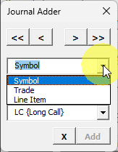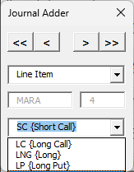
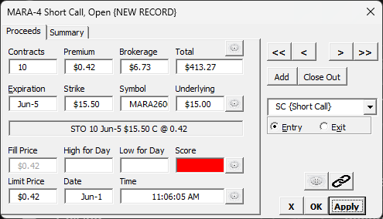
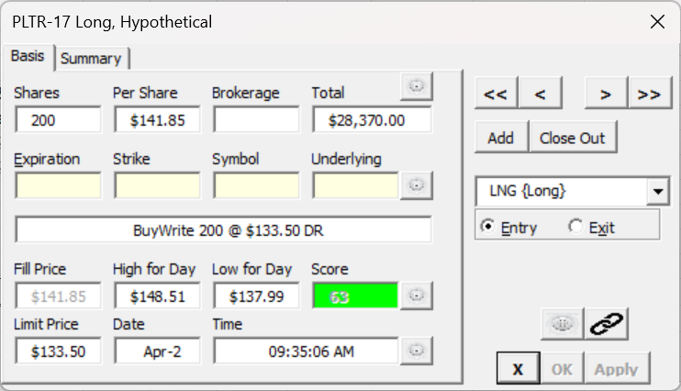
Good, I have a clear picture of the form now. Let me do the functional review properly.

Functional UI Review — Excel/VBA Option Entry Form

What the form is
A journal entry form for options positions. It has two named states visible across the screenshots: NEW RECORD (MARA-4 Short Call) and an existing record (PLTR-17 Long, Hypothetical). Two tabs: Basis and Summary.

Field inventory (Basis tab)
Top row — size/cost: Shares/Contracts · Per Share / Premium · Brokerage · Total (calculated)
Middle row — option identity: Expiration · Strike · Symbol · Underlying
Narrative bar (read-only, auto-generated):
"STO 10 Jun-5 $15.50 C @ 0.42" / "BuyWrite 200 @ $133.50 DR"
Bottom rows — fill/market data: Fill Price · High for Day · Low for Day · Score (green/red indicator) Limit Price · Date · Time
Right panel: Navigation (<< < > >>), Add / Close Out, position-type combo (LNG {Long}, SC {Short Call}, etc.), Entry / Exit radio, link/calculator icons, X / OK / Apply

Observations worth discussing
1. Two very different record types, one form The Shares label becomes Contracts, Per Share becomes Premium — the form is polymorphic based on the position type combo. This is implicit right now (label swap in VBA). Worth thinking about whether the Qt version models this explicitly.
2. Score field is a traffic-light, not a number The green 63 and the red (empty) box in the NEW RECORD case tell a story — it's a computed quality indicator, not user-entered. The color encoding (green = good score, red = no score / bad) is meaningful. Good candidate for a dedicated widget rather than a styled QLabel.
3. The narrative bar is gold "STO 10 Jun-5 $15.50 C @ 0.42" is a complete trade description synthesized from the fields. That's a great real-time validation signal — if the narrative looks wrong, something is wrong. Worth keeping prominent.
4. Expiration and Strike are yellow-tinted in the existing record but empty/white in NEW RECORD Suggests a visual convention for "this field has been filled" vs "pending". Or possibly yellow = required + unfilled? Worth clarifying — that convention needs to survive in Qt.
5. Navigation controls (<< < > >>) on a data entry form Classic journal pattern. The user is browsing a list of entries. This means the form is simultaneously a viewer and an editor — the tracker.begin_edit() / apply cycle maps directly onto this.
6. OK vs Apply OK = save and close, Apply = save and stay. Both are grayed out on the existing record (PLTR) but Apply is active on the NEW RECORD (MARA). That's the CommandBinding.is_enabled signal in action — only enabled when dirty + valid.
7. The Add / Close Out buttons These look like commands that create a new record vs. finalize a position — different lifecycle operations, not edit operations. They'd need their own CommandBinding instances, probably with different execute callables.
8. Link icon (🔗) and calculator icon Appear twice — once near Underlying and once in the bottom-right. Unclear if they're context-sensitive or always the same action. Worth clarifying — in Qt these would be QToolButtons, possibly with ButtonBinding.
9. Entry / Exit radio Only two states — maps cleanly to a bool or a two-value enum on the domain object. In Qt this would be two QRadioButtons sharing a QButtonGroup.

Key questions before designing the Qt form
- What's on the Summary tab? That could affect the overall layout strategy significantly.
The Summary Tab was never implemented and can be ignored
- Is the yellow tint "required field" or "field has a value"?
I *think* you’re referring to the form when used for Equity (PLTR-17) and the row of option specific fields that are non-enterable, and yellow). In a more thoughtful implementation the row might just be hidden,
- Does Close Out write back to the same record, or create a closing entry?
Both. Once a trade has been closed you can view that by clicking the option button “Exit”
- Are the link/calculator icons position-specific (e.g. link to the underlying's price feed)?
That was the idea – it was never implemented
- Is Score always computed, or can it be overridden manually?
Always computed
Keep in mind that while I would love to recreate the functionality of this form, we are also working out the kinks of the bindings in EbfUI. So there is a likely fair amount going on in this session before we get to the biggest pain points with the current form day-to-day

